Supply Chain Digitization — NPTEL
Week 3 | Session 4: Kraljic Matrix — Quadrant Strategies & Applications
Quick Recap — Previous Session
- Kraljic Matrix intro: 2 dimensions → Profit Impact (Y-axis) & Supply Risk (X-axis)
- Supply portfolio = all items/services procured (not the suppliers themselves)
- Procurement strategy can be defined at org level OR at individual facility level
Two Ways to Use the Kraljic Matrix
1. Starting Fresh (New Business / New Procurement)
- No history of procurement yet
- Use matrix to anticipate potential profit impact & supply risk → plan strategy proactively
2. Reviewing Existing Strategy (Established Org)
- Org has been operating 10–15 years, faces procurement issues:
  - Missed orders, supplier problems, cost overruns
  - Procured items not fitting well → impacting downstream client relationships
- Step 1 → Categorize all currently procured items into the 4 quadrants
- Step 2 → Identify what interventions are needed per category
★ Exam tip: Know both uses — proactive (new biz) vs. corrective (existing org). Always mention "segmentation first, then strategy."
Reading the Kraljic Matrix — Axis Interpretation
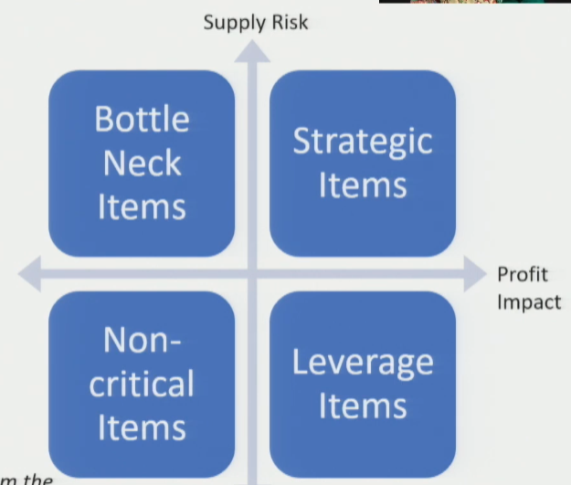
X-Axis: Profit Impact →
- Right side (High): Items contributing large % of total purchase value (30–40%) → expensive items
- Left side (Low): Cheaper items, smaller share of purchase spend
- Measured by: spend analysis, ABC analysis, VED analysis
Y-Axis: Supply Risk ↑
- Top (High risk): Few suppliers, distant suppliers, perishable items, unique specs
- Bottom (Low risk): Many suppliers, local availability, easy substitutability
- Example: Item with 1 supplier → high risk | Item with 1,000 suppliers → low risk
The Four Quadrants — Summary
- Non-Critical (Low risk + Low cost): Ideal but rare (almost impossible). Sensitive place. Easy to procure, cheap, many suppliers (may be a monopoly)
- Bottleneck (High risk + Low cost): Few suppliers but not expensive. Supply disruption is the main concern
- Leverage (Low risk + High cost): Expensive but many supplier options → buyer has negotiating power
- Strategic (High risk + High cost): Most critical. Expensive AND few suppliers → very difficult position

- Ideal goal: Push all items → Non-Critical quadrant (reduce risk + reduce cost)
- Reality: Impossible to have all items non-critical → always expect a distribution across all 4
★ Exam tip: Why can't all items be non-critical? Monopoly scenario is short-lived — competitors enter, suppliers split across clients, risk rises.
Strategic Interventions — Reducing Supply Risk
- Goal: Move Bottleneck & Strategic items → lower risk quadrants
Option 1 — Add More Suppliers
- Applicable for: Bottleneck & Strategic items
- Identify & qualify alternative suppliers to reduce dependence on one source
Option 2 — Joint Venture or Supplier Takeover
- Applicable for: Strategic items (most impactful)
- When to use: Only one supplier exists globally, item is rare, high volume procurement
- Long-term JV or acquisition of supplier → secures supply permanently
Option 3 — Carry Stock (Safety Inventory)
- Applicable for: Bottleneck items especially
- Why: High supply risk → late deliveries likely → pre-purchase excess inventory to buffer demand shocks
  - Example: Supplier is geographically far → procure large volumes in advance to handle demand variability
- Tradeoff: Higher inventory holding cost but protects production continuity
Option 4 — Find Substitutes
- Applicable for: Bottleneck & Strategic items
- Logic: High risk often comes from unique specs (chemical composition, shape, size) → if substitutes can deliver same function → supply risk distributes across more items
  - Example: Dye in shampoo → 1 supplier → high risk. Find alternative dye with same color/shine → more suppliers → lower risk
- Key question to ask: Is this specific attribute truly non-negotiable for the final product?
★ Substitution → same functional benefit → more procurement options → supply risk reduced
Strategic Interventions — Reducing Cost
- Goal: Reduce cost for Leverage & Strategic items (high profit impact side)
For Strategic Items — Cost Reduction is Hard
- Supplier is the dominating party → limited negotiation power for buyer
- Supplier's position: "I have the product, your competitors want it too — take it at my price or I go elsewhere"
- Only viable long-term option: JV / Takeover (removes supplier dominance)
For Leverage Items — Buyer Has Power
- Many suppliers in market → buyer is the dominating party
- Tactic 1: Enable competition among suppliers — invite competitive bids / tenders → drives price down
- Tactic 2: Optimize order quantity → ask for volume discounts
- Tactic 3: If no cost reduction possible → find substitutes and drop the item
★ Exam tip: Leverage items = buyer's best opportunity to reduce cost. Strategic items = supplier dominates → negotiation alone won't work.
Streamlining Procurement Transactions
- Beyond risk & cost → look at HOW procurement is done
E-Procurement / Automation
- Electronic procurement portals → reduce cost of searching & connecting buyers to suppliers
- Large growth in e-procurement seen across industries
Decentralization of Purchase Decisions
- Best for: Non-Critical items
- Since value is low + risk is low → no need for central strategic oversight
- Action: Delegate procurement to the relevant facility / division / committee
- Allow: Spot purchases based on local requirement directly from market
  - Why spot purchases work here: Prices for non-critical items are well-defined in market; suppliers won't drop cost drastically due to competition among themselves
★ Non-critical items → decentralize → spot purchases → saves management bandwidth for strategic/bottleneck items
Direction of Movement — Ideal Strategy Goals
- Bottleneck items → reduce supply risk → move towards Non-Critical
- Strategic items → reduce supply risk + reduce cost → move towards Leverage, then Non-Critical
- Leverage items → already low risk → reduce cost → move towards Non-Critical
- Non-Critical → maintain; automate & decentralize purchasing

- Practical reality: Full movement to non-critical is rarely possible (nature of product/market prevents it)
- Esp. for Strategic items: Very hard to reduce either dimension → focus on JV/takeover as long-term play
★ Exam tip: Always pair each quadrant's strategy with a reason WHY it's difficult/easy — examiner wants causal reasoning, not just labels.
Session Summary
- Matrix use: Start fresh OR review existing procurement strategy
- Risk reduction tools: Add suppliers | JV/Takeover | Carry stock | Find substitutes
- Cost reduction tools: Competitive bidding (Leverage) | JV/Takeover (Strategic) | Substitutes | Optimal order qty
- Streamlining tools: E-procurement | Decentralized spot purchasing (Non-Critical)
- Next session: Numerical example → apply Kraljic Matrix to a real case firm
★ Kraljic Matrix = classify first → then define targeted strategy per quadrant. Not a one-time exercise — revisit as markets evolve.

